

Charges and Remissions Policy
Pure College
August 2026

Contents

Background | Page 3
Charges and Remissions | Page 3
Enrichment Activities | Page 3
Residential Trips | Page 3
College Meals | Page 3
Bursary Payments | Page 4
Review of Policy | Page 4

Review of Policy Document

First copy: Jan 2023

Signed and Approved by Louise Parrot- Bates, Chief Executive:


Date: Jan 23

Reviewed/Updated
Date | Comments | Print | Sign
Jan 2023 | Policy Created | Catherine Kennedy | C.Kennedy
August 2024 | Policy reviewed | Stephen Dootson | 
August 2024 | Policy reviewed  New Additions:-  Student Residential Trip  Enrichment Activities | Amanda Noon | 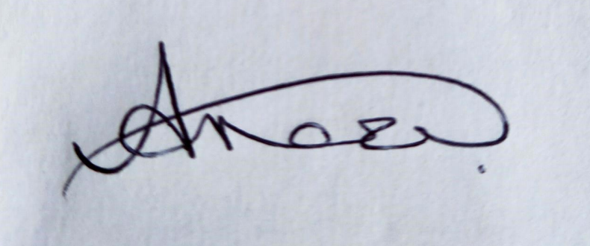
August 2026 | Policy reviewed | Kaylie Crompton | K Crompton
Policy Applies to
All Pure Innovations inclusive of Pure College
Pure College Only | √

For the avoidance of doubt and unless expressly stated to the contrary any reference to Pure Innovations should be treated as including Pure College, and any reference to client should be treated as including a Student of Pure College.

Background

Pure College is an independent specialist college providing tailored study programmes for young people aged 16 to 25. Our vision is to be the College of choice empowering our learners to be resilient, independent and lead valued lives in their community.
The College is funded through a combination of fees paid by the young person’s home local authority and the Department for Education. Our future aim is to seek voluntary contributions/income to fund the College’s development, research, and evaluation to provide support and additional resources.

Charges and Remissions

As a ‘day’ College, all activities that are part of our curriculum and the young person’s study programme are provided free of charge to our students, as these elements are covered by the funding allocations outlined above.

Enrichment Activities

Pure College offer a range of enrichment activities for our students to supplement their academic studies. Students are encouraged to get involved and experience as many different opportunities as possible. Most enrichment activities are free of charge however, there are some that require additional financial contribution. These include:-

- Bus Fair for all trips if the student doesn’t have a bus pass
- Cooking and Termly enrichment trips – these are heavily subsidised. College request a nominal contribution – the amount will be confirmed by letter and regular communication home.

Residential Visits

In partnership with Greater Manchester Youth Foundation (GMYF), Pure College offer a non-mandatory 2/3 day Residential Programme towards the end of the academic year for up to twelve students. The residential is part subsidised by GMYF, however we will be requesting students and families to provide a financial contribution towards Board and Lodgings to enable the residential to take place. It may also be possible for a student to draw down bursary funding to cover such costs, where the guidance and criteria considers this permissible.

College Meals

There are no catering facilities in college. Young people may bring a packed lunch to college or purchase food from external providers. Some students may be eligible to a free College meal. Please refer to the Financial Support section of the college website for further information.

Bursary Payments
The bursary fund is intended to help students with the essential costs of participating in their study programme. Help with the cost of essential books or equipment or with the cost of travelling to college, for example. The bursary fund is not intended to support costs not related to education (living costs), extra-curricular activities or provide learning support – services that institutions give to students – such as counselling, mentoring or extra tutoring. There are separate funds for 16–18-year-olds and 19–24-year-olds.

Review of Policy
The policy will be reviewed annually.

