Examinations and Accreditations
Pure College


6/7/2024
Rationale 1
1. Registration and Certification 1
2. Withdrawal 2
3. Assessment 2
4. Internal Quality Assurance 3
5. Enquiry and Appeals 4
6. Malpractice 5
7. Responsibilities 6

Revision History
Reviewed/Updated

Date | Comments | Print | Sign
Sept 22 | Policy Created | LPB | 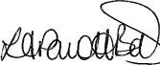
May 24 | Policy reviewed | KC | K Crompton
May 25 | Policy reviewed and approved | KC | K Crompton
Jan 26 | Policy reviewed – clarified GDPR | KC | K Crompton

Policy Applies to
All Pure Innovations inclusive of Pure College
Pure College Only | X

Rationale
The Vision of Pure College is to develop the skills and resilience of young people for life and the world of work and we do this by providing a broad and balanced, ambitious curriculum which ensures students are supported in their learning so that they are able to make good progress from their individual starting point.
Pure College provides qualifications and accreditation at varying levels to support long term plans for the future. Assessment methods are both formative and summative and are an opportunity for both students and tutors to evaluate the learning that has taken place and plan next steps which may include further education and / or employment.
Examinations serves four fundamental purposes:
- To provide broad, ambitious and sequential coverage of the topics that students will cover.
- To help students learn by providing a method of assessing progress and understanding through standardised tests.
- To provide accurate attainment data for students, parents, carers and local authorities.
- To create opportunities for students who may wish to seek further education or employment.
This policy covers the aims and Pure College’s commitment in the following areas:
- Registration and Certification
- Assessment
- Internal Verification
- Appeals
- Malpractice
It also clearly defines the responsibilities of each role within the registration, delivery, assessment and claim of any examination or accreditation within Pure College.

Registration and Certification
Aim:
- To register individual students to the correct programme within agreed timescales.
- To claim valid student certificates within agreed timescales.
- To construct a secure, accurate and accessible audit trail to ensure that individual student registration and certification claims can be tracked to the certificate which is issued for each student.
In order to do this, Pure College will:
- Register each student within the awarding body requirements
- Ensure communication between Curriculum and Quality Manager, assessors and internal verifiers provides a way to check the accuracy of student registrations
- Make each student aware of their registration status where appropriate
- Inform the awarding body of withdrawals, transfers or changes to student details
- Upload and verify all results via the Portal within 12 weeks of the end date of the course
- Keep all records safely and securely for three years post-certification.
All personal data relating to assessment, registration, certification and appeals is processed in accordance with the UK General Data Protection Regulation (UK GDPR) and the Data Protection Act 2018. Records are stored securely, accessed only by authorised staff, and retained in line with awarding body and statutory requirements.

2. Withdrawal

Students’ progress against the accreditation objectives is continually assessed by the Tutor and Curriculum Quality Manager, and in the unlikely event that withdrawal is required, the process will follow a two‐stage process:
Stage 1 – Decision to withdraw
All current qualifications will be reviewed by the Curriculum and Quality Manager and Head of College as and when required. They will consider entry data, attainment levels and qualification relevance in line with the Long-Term Aspirations as outlined in student’s Education Health and Care Plan.
Stage 2 – Managing the Withdrawal
Upon the decision being made to withdraw a qualification, arrangements will be made for the students to continue their learning along an individualised, basic skills-based timetable.
The withdrawal will be communicated to the awarding organisation, regulatory authorities and the ESFA via the IRL.

3. Assessment
The Open Awards Vocational Courses along with Functional Skills Qualifications have been designed around the principle that students will build evidence towards the achievement of the Assessment Criteria over a period of time. Assignment Briefs are implemented and pre-verified for medium and high-risk qualifications and these are upload to the Portal.
Aim:
- To ensure that assessment strategies are clear, reliable and consistent across Pure College and generate sufficient evidence to show how students have met the learning outcomes and assessment criteria.
- To ensure that the assessment procedure is open, fair and takes into account any special considerations for each student.
- To ensure that there is accurate and detailed recording of assessment decisions that can be evidenced and verified.
In order to do this, Pure College will ensure that:
- The Qualification Assessment Plan is completed and uploaded onto the Portal.
- Students are provided with assignments that are fit for purpose, and are able to produce appropriate evidence for assessment.
- Assessors and Teachers develop assessment procedures that will minimise the opportunity for malpractice.
- Assessments are scheduled across the programme to ensure that students are not over-assessed at any given point.
- Assessors, Internal Verifiers and Tutors maintain accurate, detailed and secure records of assessment decisions.
- A robust and rigorous internal quality assurance procedure is in place.
- Samples are provided for quality assurance as required.

4. Internal Quality Assurance (IQA)
At Pure College we operate rigorous internal quality assurance systems. The Curriculum Quality Manager is the Quality Contact who oversees the IQA of all delivery of Open Awards qualifications and units

Aim:
- Assessment is appropriate, consistent, fair and transparent and does not unintentionally discriminate against any student.
- Tutors/assessors receive ongoing advice and support, for example in designing assessment activities.
- Students clearly understand assessment requirements and are given opportunities to achieve against the assessment criteria by completing appropriate assessment tasks.
- Students’ work is presented in a manner that enables effective verification to take place.
- Students’ assessed work is authentic.
- Evidence of student achievement is clearly mapped to the assessment criteria.
- Recommendations for the award of credit are valid, reliable, and consistent.
In order to do this, Pure College will ensure that:
- An identified individual - the Curriculum and Quality Manager - is responsible for coordinating internal quality assurance processes.
- There are clear and documented roles and responsibilities for all those involved.
- All students are assessed accurately, fairly, and consistently to the right standard.
- Internal quality assurance is structured and incorporates all of a Provider’s Open Awards provision.
- Assessment tasks and student work are sampled appropriately.
- Good practice is promoted through internal standardisation events and quality assurance meetings.
- Decisions are supported by full and clear records and action plans that are followed.
- Internal processes are transparent and regularly evaluated.
Pure College Internal Verification Cycle:
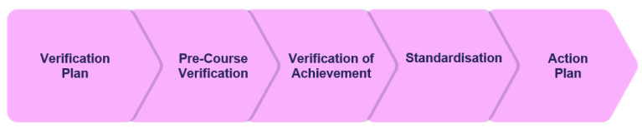
Full details of the verification process can be found on page 45 of the Open Awards Centre Handbook; Microsoft Word - Centre Handbook 2018 (openawards.org.uk)

5. Controlled Assessments

Pure College will ensure that all controlled assessments take place in an appropriate assessment environment.
Pure College will ensure that:
- The venue meets the requirements of the examining body
- Pure College will advise Open Awards of the location of the venue before the assessment takes place.
- Open Awards are welcome to visit the College should they require access to the venue for the purposes of inspection and/or spot checks.
- The handling and storage of assessment materials is carried out with regard to the security and integrity of assessment materials, before, during and after the assessment.
- We maintain records of how assessment venues meet these requirements, which must be made available to Open Awards on request.
The assessment location and environment:
- Assessments will take place in a classroom which will be dedicated to the sole purpose of controlled assessments for the duration of the assessment.
- The classroom temperature is managed through a heating and air conditioning unit.
- The classroom is a familiar space for students with overhead lighting.
- Controlled assessments will take place when the college is quiet and the noise around the assessment room can be maintained.
- Appropriate spacing will be maintained to ensure assessment integrity and candidate comfort.
- Space for the invigilator will be sufficient.
- A seating plan will be in place and the information retained for one year following the assessment.
- Display materials such as posters, wall charts, information leaflets or other visual stimuli which might be helpful to students will not be visible in the assessment room.
- The following items will be on display in the assessment room: A poster advising students that mobile devices are not allowed in the assessment room, Assessment warning notice for learners, Centre appeals procedure, Emergency/evacuation procedures, Start/finish times, and date, of the assessment, Centre number, A reliable clock (or other suitable time keeping device e.g. time displayed via a computer screen) must be visible to each learner in the assessment room and the clock/display must be large enough for all learners to read clearly.
- Signage will be clearly visible to others in the College, advising that an assessment is taking place.
The invigilator will follow the guidelines as stated in the Open Awards; Instructions for Conducting Controlled Assessments.

Definitions
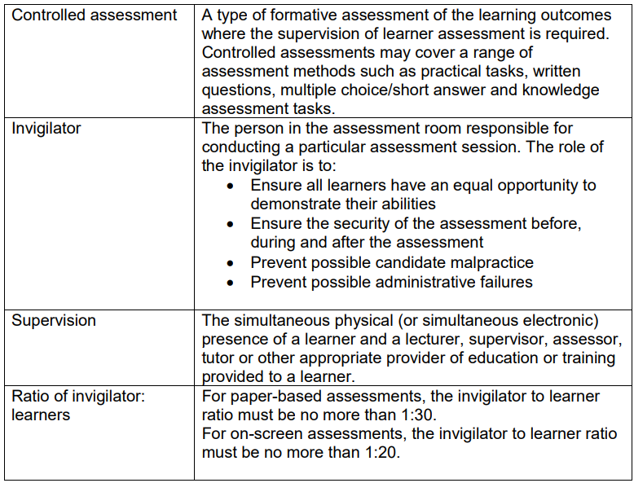

6. Enquiry and Appeals

This section of the policy addresses the situation where students may wish to make an enquiry or appeal against an outcome they have received for a qualification.
All students at Pure College have the right to make an enquiry or appeal about the outcome received for the qualifications they are undertaking.
An enquiry about a controlled assessment result gives the opportunity for a student or provider to question the result of an assessment marked by Open Awards if they believe the marking was inaccurate.
The College can submit an enquiry on behalf of a student or group of students, with their explicit written permission. For each enquiry, written permission should be obtained.
If any student wishes to appeal a decision, they should follow the following procedure:
- If possible, speak to the tutor in the first instance about the reason they wish to appeal.
- The tutor has a responsibility to explain to the candidate why they received the outcome.
- If the student is not satisfied with the explanation, the piece of work will be re-assessed by another qualified assessor who has not been involved in the initial quality assessment process. At Pure College this would usually be the Head of College.
- The student will be informed of the outcome of the re-assessment.
- If the student wants to continue the appeal, they need to contact the Quality Contact (Curriculum and Quality Manager), who will provide the student with information about the appeals procedure and explain what is involved.
This appeals process relates specifically to assessment decisions and operates alongside, but separately from, the College Complaints Policy.

7. Malpractice
This section of the policy sets out to define the procedures to be followed in the event of any dispute or allegation regarding staff malpractice in the valuation of internally assessed qualifications and also regarding examinations invigilated by staff and assessed externally. The Head of College is responsible for reporting all cases of Malpractice to the Awarding Body.
Examples of Malpractice:
Attempted or actual malpractice activity will not be tolerated. The following are examples of malpractice by staff or other candidates with regards to portfolio-based qualifications. This list is not exhaustive:
- Tampering with students work prior to external moderation/verification.
- Assisting students with the production of work outside of the awarding body guidance.
- Fabricating assessment and/or internal verification records or authentication statements.
The following are examples of malpractice by staff or other candidates with regard to examinations
- Assisting candidates with exam questions outside of the awarding body guidance.
- Allowing candidates to talk, use a mobile phone or go to the toilet unsupervised.
- Tampering with scripts prior to external assessments taking place.
All supporting documentation, including the use of calculators and dictionary / thesaurus, are stored in a locked cupboard. Resources used for exams are only to be used for this purpose. These resources are checked prior to each examination by the assessor and centre lead.
Staff Malpractice Procedure
Investigations into allegations will be coordinated by the Head of College. The initial investigation will be carried out within ten working days. The investigation will involve establishing the full facts and circumstances of any alleged malpractice. It should not be assumed that because an allegation has been made, it is true. Where appropriate, the staff member concerned and any potential witnesses will be interviewed and their version of events recorded.
The member of staff will be:
- informed in writing of the allegation made against them
- informed what evidence there is to support the allegation
- informed of the possible consequences, should malpractice be proven
- given the opportunity to consider their response to the allegations
- given the opportunity to submit a written statement
- given the opportunity to seek advice (as necessary) and to provide a supplementary statement (if required)
- informed of the applicable appeals procedure, should a decision be made against them
- informed of the possibility that information relating to a serious case of malpractice will be shared with the relevant awarding body
- If work is submitted for moderation/verification or for assessment, which is not the candidate’s own work, the awarding body may not be able to give that candidate a result.
Where there is evidence from the investigation that a member of staff may be guilty of malpractice, the Disciplinary Policy and Procedure of Pure College will be invoked.
Maladministration
The Head of College will ensure that they will inform the Awarding Body immediately if they are aware that maladministration has occurred, for example incorrect completion of registration of candidates or units and / or incorrect claims for candidate certification.
Whistleblowing
Pure College will always aim to keep a whistle-blower’s identity confidential where asked to do so. The investigator reviewing the allegation will not reveal the whistle-blower’s identity unless the whistleblower agrees or it is absolutely necessary for the purposes of the investigation. The investigator will advise the whistleblower if it becomes necessary to reveal their identity against their wishes.

8. Access to Fair Assessment

Pure College is committed to ensuring access to fair assessment for all students and apprentices, as well as protecting the integrity of the award of qualifications and units. There may be circumstances in which arrangements need to be made to take account of a particular student’s requirements in order to ensure that this is achieved without giving any unfair advantage over other students.

Reasonable Adjustments
Pure Innovations is committed to ensuring the rights of individual students to access qualifications, units and assessments in a way most appropriate for their individual needs and to enable them to demonstrate their achievements. At the same time, we are committed to ensuring that the integrity of our qualifications, units and assessment is maintained at all times.
A student will be eligible for reasonable adjustments if their performance during an assessment is likely to be substantially affected by a particular impairment. Many of these students will be defined as being disabled under the Disability Discrimination Act 1995, and the Equality Act 2010.
An adjustment to assessment should only be considered where the difficulty experienced places the student at a substantial disadvantage, in comparison with persons who are not disabled. Where the difficulty is minor, the provider should assist the individual by offering help with study and assessment skills.
A student does not necessarily have to be disabled (as defined by the Disability Discrimination Act 1995 and Equality Act 2010) to be entitled to reasonable adjustments to assessment. Every student who is disabled will also not necessarily be entitled to or need an adjustment to assessment. The student may have developed coping mechanisms which minimise or remove the need for assistance.
Different types of assessment make different demands on students and will influence whether reasonable adjustments will be needed and the kind of suitable reasonable adjustment which may be put in place.
Where applicable, access arrangements will be applied in line with Open Awards guidance and evidence of need.
The adjustments that are appropriate for a particular assessment will depend upon:
- the specific assessment demands of the qualification/unit
- the type of assessment
- the particular needs and circumstances of the individual student.

9. Responsibilities

The Head of College is responsible for:
- Management and delivery of examinations and qualifications at Pure College.
- Ensuring students are registered on time and correctly.
- Claiming valid student certificates within agreed timescales.
- Ensuring that Pure College acts in accordance with the conditions of approval, regulations and any other terms and conditions or policies for each awarding body.
- Ensuring that all quality assurance processes are conducted efficiently.
- Reporting incidents of Malpractice or Maladministration to the appropriate body.
The Quality Contact (the Curriculum and Quality Manager) is responsible for:
- Ensuring effective management of Pure College course programmes and actively promoting good practice.
- Being the main point of contact for the External Quality Assessor. They will agree the agenda of the visit, negotiating when this will take place and which practitioners need to be involved.
- The accountability for the quality assurance across each subject area.
- Verifying and signing off assignment briefs.
- Ensuring all assessment and verification records are available for scrutiny and be able to confirm that work is authentic and valid.
- Authorising resubmissions fairly and consistently.
- Ensuring that feedback and outcomes of internal and external moderation support future development of good practice
Tutors / Assessors are responsible for:
- Ensuring that the curriculum plans and assignment briefs meet the criteria of the course specification.
- Assessing students against the learning aims and assessment in a timely way.
- Providing assessment records and students work for Quality Assurance, and undertake any action required to bring the assessment in line with national standards.

